1. select b.branch_zip, sum(cc.transaction_value) as `sum_of_transactions`

from cdw_sapp_d_branch b

left join cdw_sapp_f_credit_card cc

on b.branch_code = cc.branch_code

group by b.branch_zip

order by `sum_of_transactions` desc

limit 20;

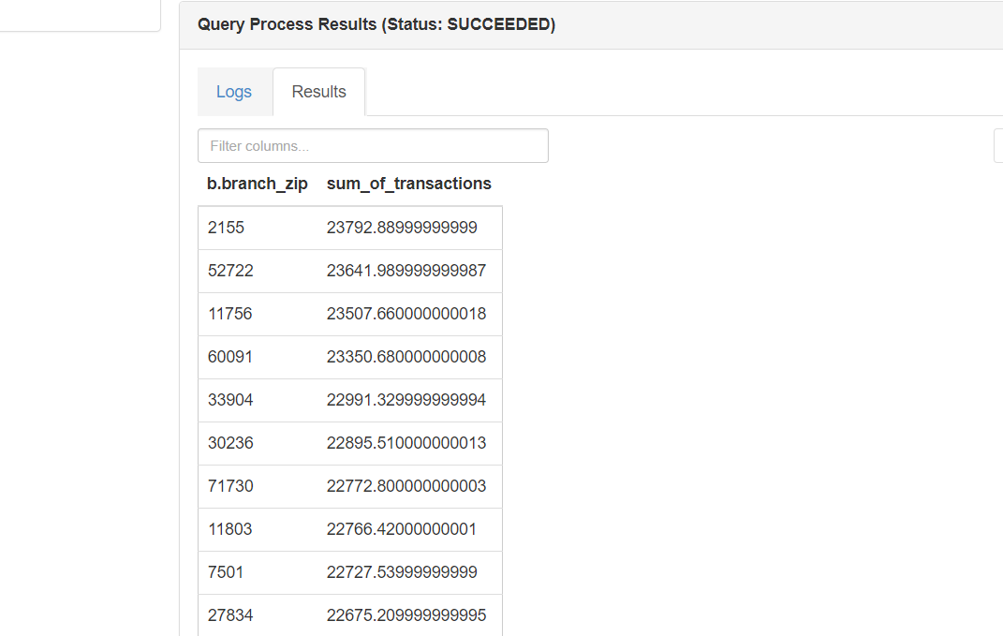

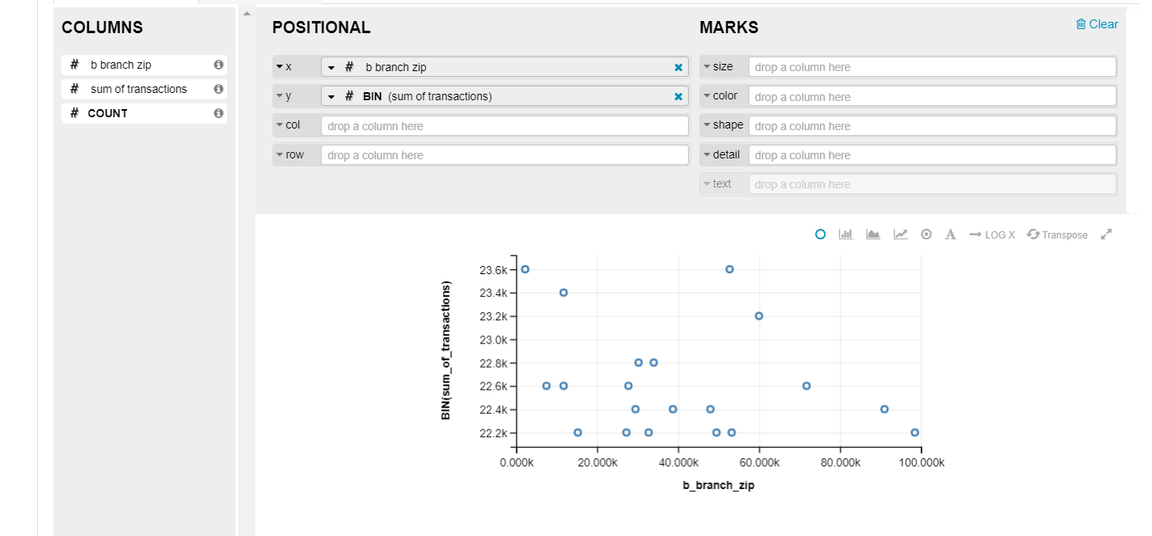

2. Select sum(CC.TRANSACTION_VALUE) as Total_Transaction_Value,

CC.TRANSACTION_TYPE as Transaction_Type,

T.qtr as Quater

from cdw_sapp_f_credit_card CC

join cdw_sapp_d_time T

on (CC.time_id = T.timeid)

group by CC.TRANSACTION_TYPE, T.qtr;

